CSIT314 Software Development Methodologies - Group Project

Sprint 4 - US35: View saved list
Interior Design Platform - Customer
All diagrams were drawn in draw.io. Open "US35 View saved list.drawio" in this folder to edit them - each diagram is its own page in that file. The exported images are in the "diagrams" folder.

Assumptions
- The system is the Interior Design Platform from the project specification. Sprint 4 covers the Interior Designer's past IDP stories (US25 - US29) and the Customer's saved list stories (US33 - US35).
- We follow B-C-E: the actor only talks to the boundary (page), the boundary only talks to the controller, and the controller works with the entity classes. There is one controller per use case.
- Who checks what: the boundary checks all the input (required fields, lengths, formats, e.g. not suspending your own profile) and trims spaces, then passes an entity object on. The controller just calls the entity and returns the result. The entity checks for duplicates and the database state (e.g. name already used, only Active rows are changed), then saves. In US35 there is no typed input: the page passes the logged-in customer's id. ViewSavedListController.getSavedList(customerId) just calls SavedIDP.getSavedRecords(customerId) and returns the list - no checks. The entity only reads this customer's saved list and leaves out IDPs customers can no longer see.
- Being logged in as a Customer (UC30) is the precondition, so the page and the diagrams don't check the customer again (no CustomerLoginController). customerLoginRequired in app.py only sends someone with no session to /customer/login. The customerId is always session["userId"], never a value from the page.
- Managing the saved list (the US30 user story says customers log in to "view and manage my saved IDPs") means saving an IDP (US33), viewing the saved list (US35) and searching it (US34) only. There is no remove / unsave.
- The list shows every IDP the Customer saved, most recently saved first. Each card shows the title, category, location (if any) and project type (Current or Past), with View, which opens the IDP's details (US32).
- Saved IDPs that were deleted or whose category was suspended are left out of the list (the saved_idp row stays in the database).
- Nothing saved yet → "You have not saved any IDPs yet" (MSG_NO_SAVED). Viewing the saved list never changes any data.
- The search bar on the same page is US34 Search saved list. The page class SavedListPage is shared by US35 and US34, but each use case has its own controller.

1. User story
Story ID | US35
User story | As a customer, I want to view my saved list so that I can see all the IDPs I have saved.
Actor | Customer
Priority | To be agreed
Story points (estimate) | To be agreed
Acceptance criteria | 1. Given I am logged in as a customer, when I click "Saved IDPs" on the dashboard or the sidebar, then I see every IDP I saved, most recently saved first.  2. Each saved IDP shows its title, category, location and project type, and View opens its details.  3. Saved IDPs that were deleted or whose category was suspended are not shown.  4. Given I haven't saved any IDPs, I see "You have not saved any IDPs yet".  5. I only see my own saved IDPs.  6. Given I am not logged in, when I open Saved IDPs, then I am sent to the customer login page.
Tasks | #194 Draw Use Case Diagram and Write Use Case Description  #202 Draw BCE and Sequence Class Diagram  #210 Develop the Saved List page to retrieve and display projects saved by the customer.  #254 Design Wireframe  #255 Write and Execute Test Cases

2. Use case diagram
The user story becomes one use case, UC35 View saved list. The Customer is the only actor. Being logged in (UC30) is the precondition; IDPs get into the list with UC33 Save IDP, the search bar on the page is UC34, and View opens UC32 View IDP.
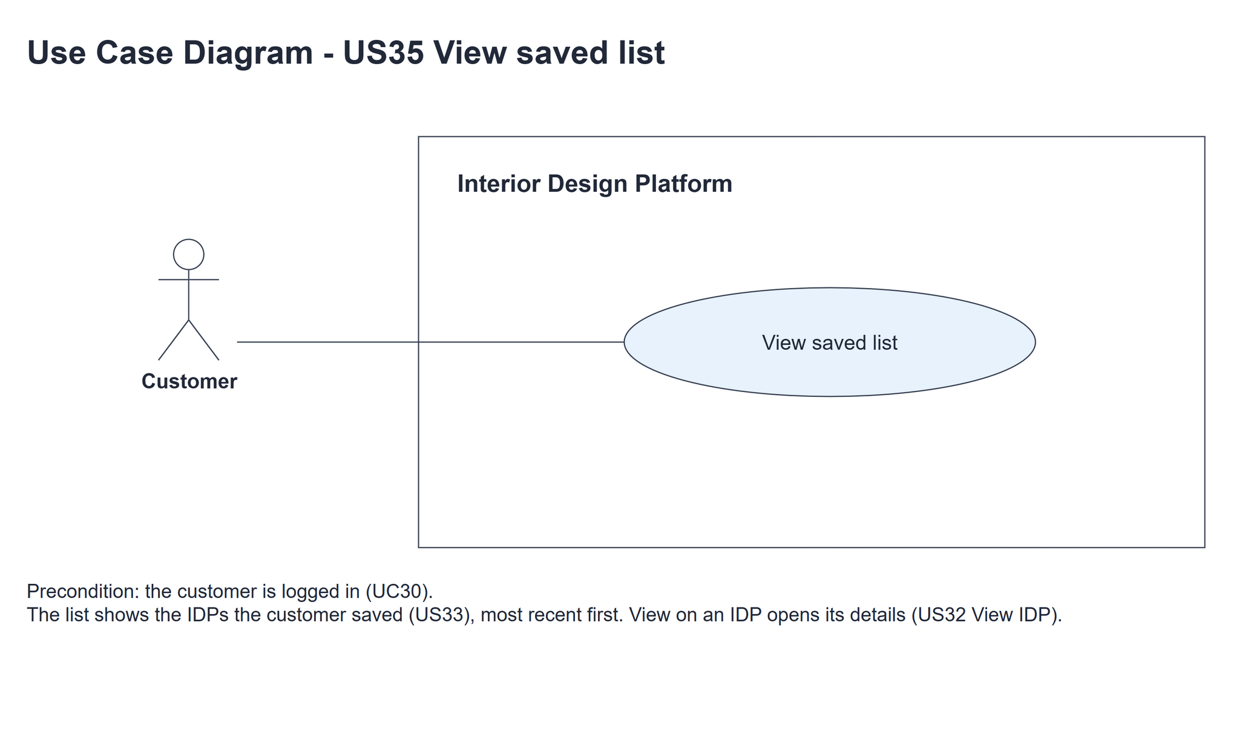
Figure 1: Use case diagram for US35 View saved list

3. Use case description
Use case | UC35 View saved list
Actor | Customer
Brief description | The Customer opens their saved list to see all the IDPs they have saved.
User story | US35: As a customer, I want to view my saved list so that I can see all the IDPs I have saved.
Preconditions | The Customer is logged in (UC30).
Trigger | The Customer clicks "Saved IDPs" on the dashboard or the sidebar.
Basic flow | 1. The Customer clicks "Saved IDPs".  2. The system gets the logged-in Customer's saved IDPs, leaving out IDPs that were deleted or whose category was suspended, most recently saved first.  3. The system shows the saved IDPs - title, category, location and project type - each with View, and the search bar (UC34).
Alternative flows | 2a. The Customer hasn't saved any IDPs (or none of them is still available): the system shows "You have not saved any IDPs yet".
Postconditions | The Customer's saved IDPs (or the empty message) are shown. No data is changed.

4. Wireframes
The wireframes were drawn in draw.io. They are low-fidelity: they show the layout and the flow, not the final colours. They follow customerBase.html, savedList.html and static/style.css.

4a - Saved list
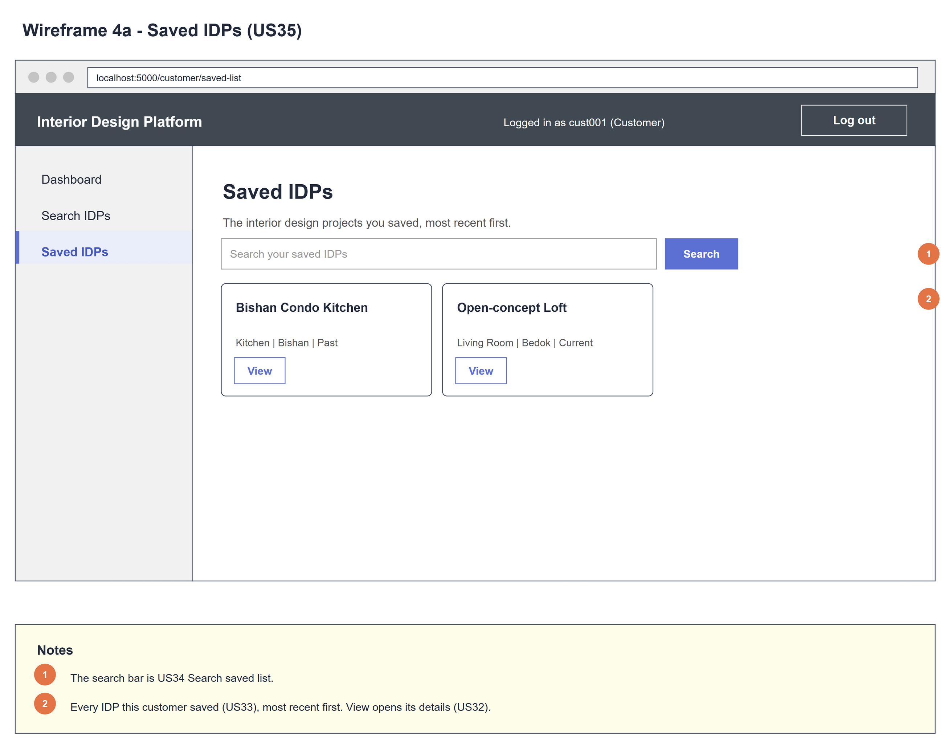
Figure 2: Wireframe 4a - Saved list (US35)

4b - Nothing saved yet
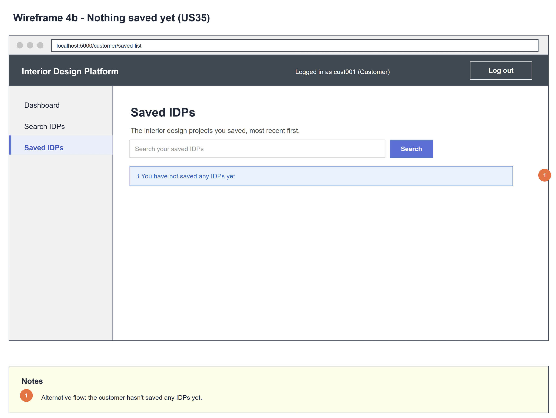
Figure 3: Wireframe 4b - Nothing saved yet (US35)

5. B-C-E class diagram
The solid line means the boundary calls the controller. The dashed line means the controller uses the entity class. Only the operations needed for this use case are shown, with the same names as the code.
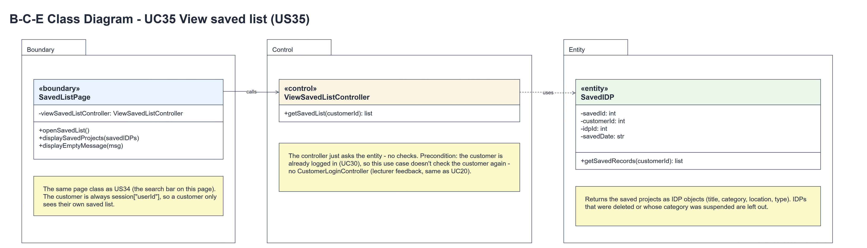
Figure 4: B-C-E class diagram for US35 View saved list
Layer | Class | What it does
Boundary | SavedListPage | The Saved IDPs page (shared with US34). openSavedList() calls getSavedList(session userId), then displaySavedProjects(savedIDPs), or displayEmptyMessage(MSG_NO_SAVED) when the list is empty.
Control | ViewSavedListController | Controller for UC35. getSavedList(customerId) just calls SavedIDP.getSavedRecords(customerId) and returns the list - no checks.
Entity | SavedIDP | The only entity. getSavedRecords(customerId) returns the customer's saved IDPs as IDP objects (with categoryName) - only Active IDPs in Active categories, most recently saved first.

6. Sequence diagram
The sequence diagram follows UC35. The page passes the logged-in customer's id to the controller (step 2), which makes one call to SavedIDP.getSavedRecords(customerId) (step 3) and returns the list (steps 4-5). The alt shows the two endings: the saved IDPs, or "You have not saved any IDPs yet" (alternative flow 2a). Viewing has no typed input, so there is no [input is valid] alt.
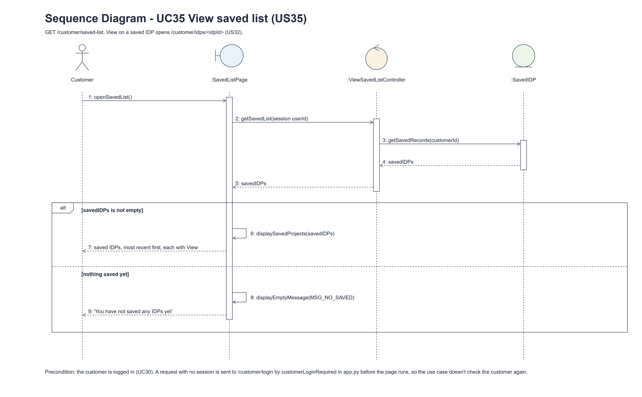
Figure 5: Sequence diagram for UC35 View saved list

7. Test cases
Test data used below (same as the test file): an interior designer with IDPs in the Kitchen and Bedroom categories, and the customer cust001 / Cust@123 with two saved IDPs and one IDP that is not saved. Tests use an isolated database.

7a. System test cases (black box)
Equivalence partitioning and boundary value analysis were used to pick the test data. Fill in "Actual result" and "Pass/Fail" after running each test.
Test ID | Scenario | Prerequisites | Test steps | Test data | Expected result | Actual result | Pass / Fail
TC35.1 | Open Saved IDPs | Two IDPs saved. | Click Saved IDPs in the sidebar. | Two saved IDPs | Both IDPs shown with title, category, location, type and View; the unsaved IDP isn't shown.
TC35.2 | Most recently saved first | IDPs saved on 1 Nov and 5 Nov. | Open Saved IDPs. | Two saved dates | The IDP saved on 5 Nov is first.
TC35.3 | View a saved IDP | One IDP saved. | Click View. | Saved IDP | Its details page opens (US32).
TC35.4 | Hidden IDPs | A saved IDP is deleted; another one's category is suspended. | Open Saved IDPs. | Suspended IDP; Suspended category | Neither is shown.
TC35.5 | Nothing saved yet | The customer has no saved IDPs. | Open Saved IDPs. | No saved IDPs | "You have not saved any IDPs yet".
TC35.6 | Only my saved list | Another customer saved other IDPs. | Open Saved IDPs as cust001. | Two customers | Only cust001's saved IDPs are shown.
TC35.7 | Not logged in | Signed out. | Open /customer/saved-list. | No session | Sent to the customer login page.
TC35.8 | Links | Customer logged in. | Open the dashboard. | - | The dashboard card and the sidebar both link to Saved IDPs.

7b. Unit test cases (for TDD)
These are written before the code (test-driven development) and run automatically in the CI pipeline. They cover normal inputs, abnormal inputs and boundary values. Each one matches a test function in tests/test_us35_viewSavedList.py (UT35.1 is test_ut35_1_...). Controller means ViewSavedListController; Boundary means SavedListPage. "Pass" is from the pytest run on 10 November 2026.
Test ID | Class and method | Input / setup | Expected output | Type | Pass / Fail
UT35.1 | SavedIDP.getSavedRecords() | Two saved IDPs and one IDP that isn't saved. | Only the two saved IDPs. | Normal | Pass
UT35.2 | SavedIDP.getSavedRecords() | IDPs saved on 1 Nov and on 5 Nov. | Most recently saved first. | Normal | Pass
UT35.3 | SavedIDP.getSavedRecords() | One saved IDP Suspended, the other one's category Suspended. | Empty list. | Abnormal | Pass
UT35.4 | SavedIDP.getSavedRecords() | Saved Current IDP in Kitchen. | An IDP object with categoryName "Kitchen" and projectType "Current". | Normal | Pass
UT35.5 | Controller.getSavedList() | Two saved IDPs. | The entity's list is returned unchanged. | Normal | Pass
UT35.6 | Boundary.openSavedList() (GET) | Two saved IDPs. | The Saved IDPs page lists both with View links to /customer/idps/...; the unsaved IDP isn't shown. | Normal | Pass
UT35.7 | Boundary.openSavedList() (GET) | Nothing saved. | MSG_NO_SAVED shown. | Boundary | Pass
UT35.8 | customerLoginRequired (app.py) | GET /customer/saved-list, not logged in. | Redirects to /customer/login. | Abnormal | Pass
UT35.9 | Dashboard and sidebar | GET /customer/dashboard. | Two links to /customer/saved-list. | Normal | Pass

